For workbench, you have to create a new connection and use ip as to localhost.

For workbench, you have to create a new connect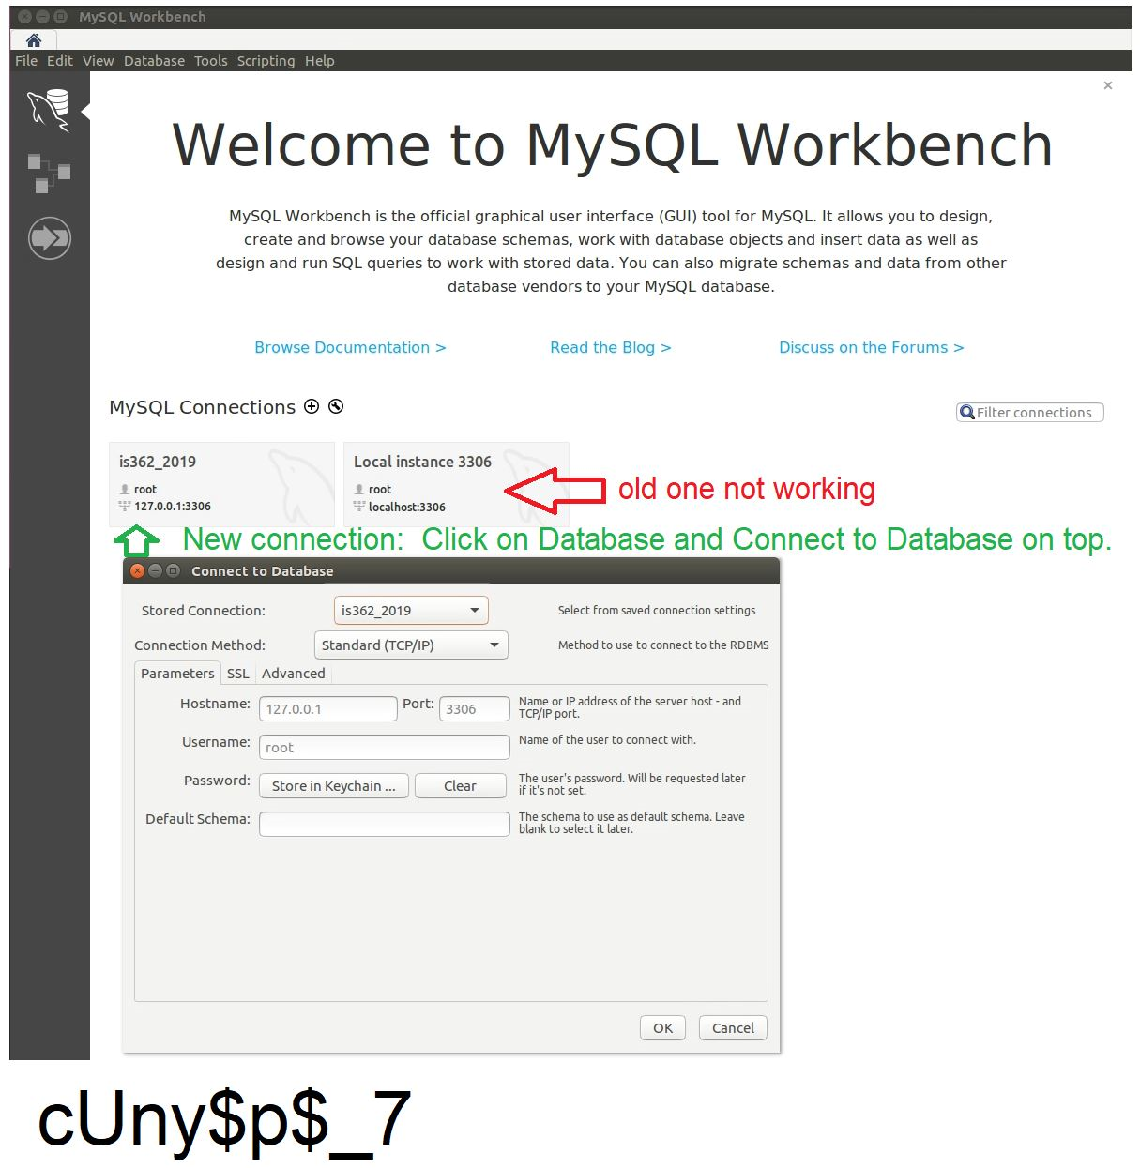ion and use ip as to localhost.

For Tableau, goto https://www.tableau.com/products/desktop/download and follow the below instructions.

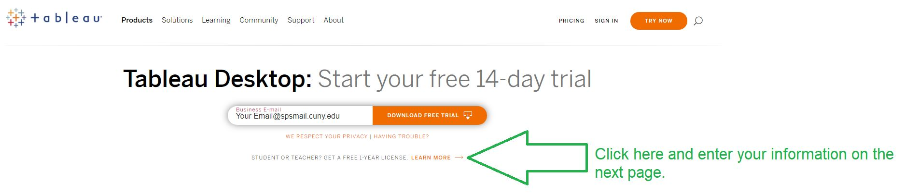

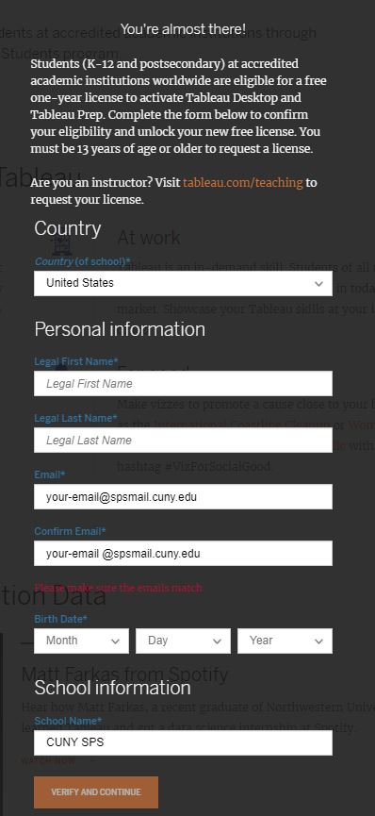

After you got through the below, you might encounter errors (secure-file-priv) when loading the script file.  Below is the workaround to load the sql file in ubuntu.  I tried to select Server to get to the options but it was grey out.  So I had to resort in command line after I escalate to root.

I opened 2 terminal session.  The top session windows tells me what secure_file_priv is pointing to.

The 2nd terminal windows copy the extracted files to that location.

**cp -i /home/your_extracted_files_directory/*.* /var/lib/mysql-files/**

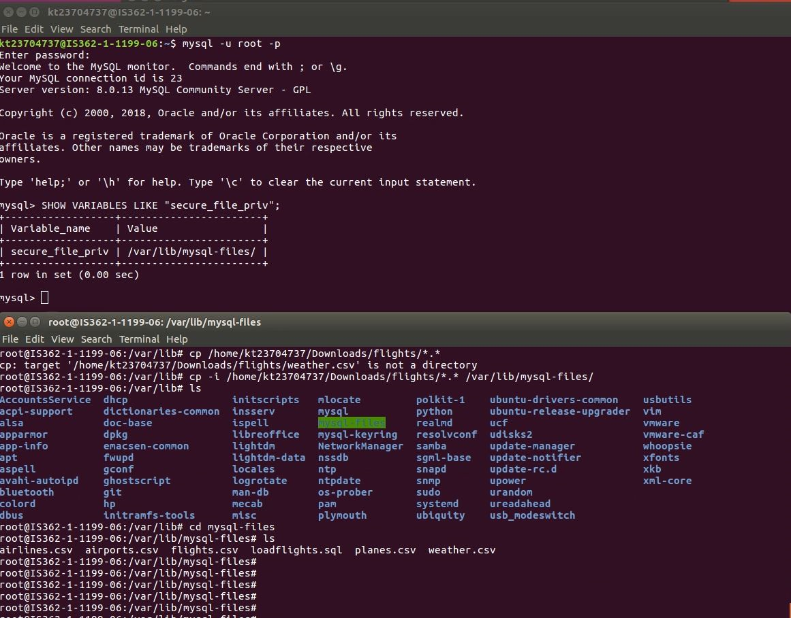

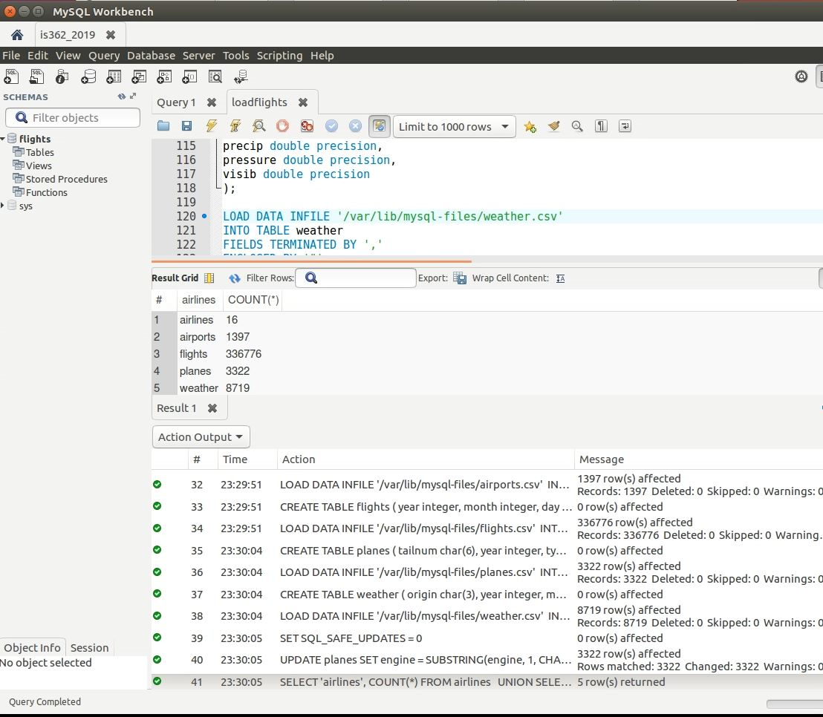

The steps that you outlined above are normally all the steps needed to connect. Did you ever uninstall and reinstall MySQL Server or Workbench? If you did, do you recall if you were prompted to set a root password? When I updated my settings after receiving the email from the SPS Helpdesk, my setup looks like the below:

When I double click on my the local instance, it connects to the database and opens up a tab with the name of the local database connection.

The steps that you outlined above are normally all the steps needed to connect. Did you ever uninstall and reinstall MySQL Server or Workbench? If you did, do you recall if you were prompted to set a root password? When I updated my settings after receiving the email from the SPS Helpdesk, my setup looks like the below:

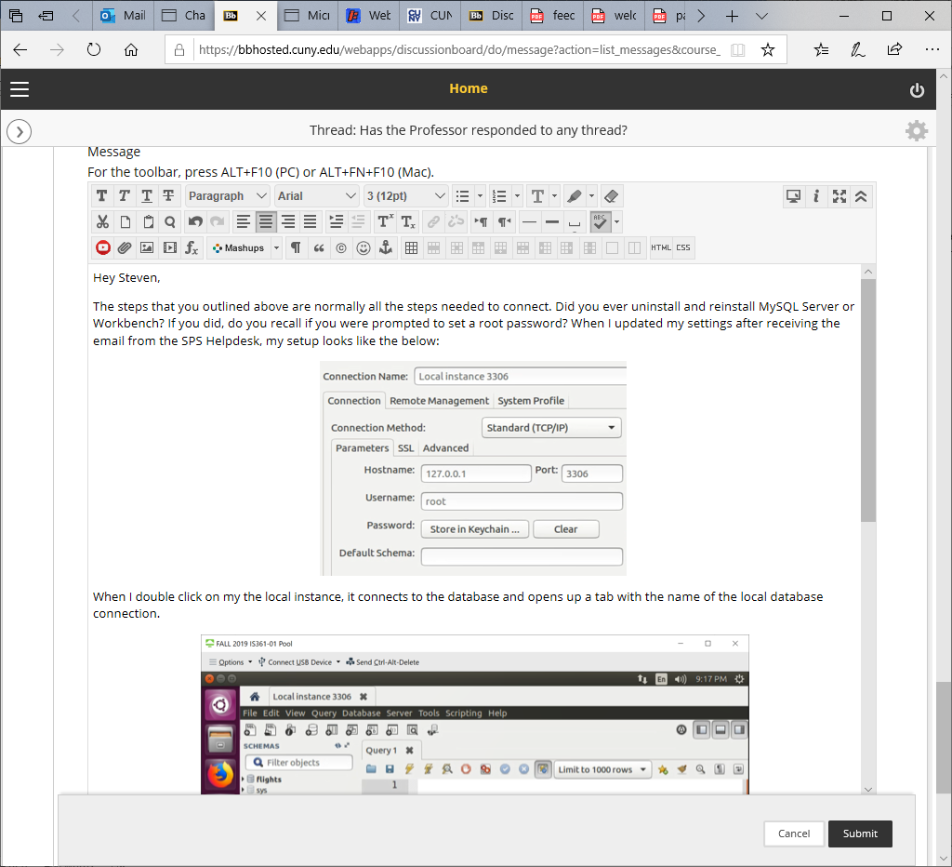

When I double click on my the local instance, it connects to the database and opens up a tab with the name of the local database connection.

If it's still now working, one thing you can try doing is to see if the MySQL server is running on your VDI.

1) Open up a terminal

2) Type in the command: service mysql status

3) You should see something similar to the below where it's active (running)

If your server is not active, try running this command in the terminal: service mysql restart

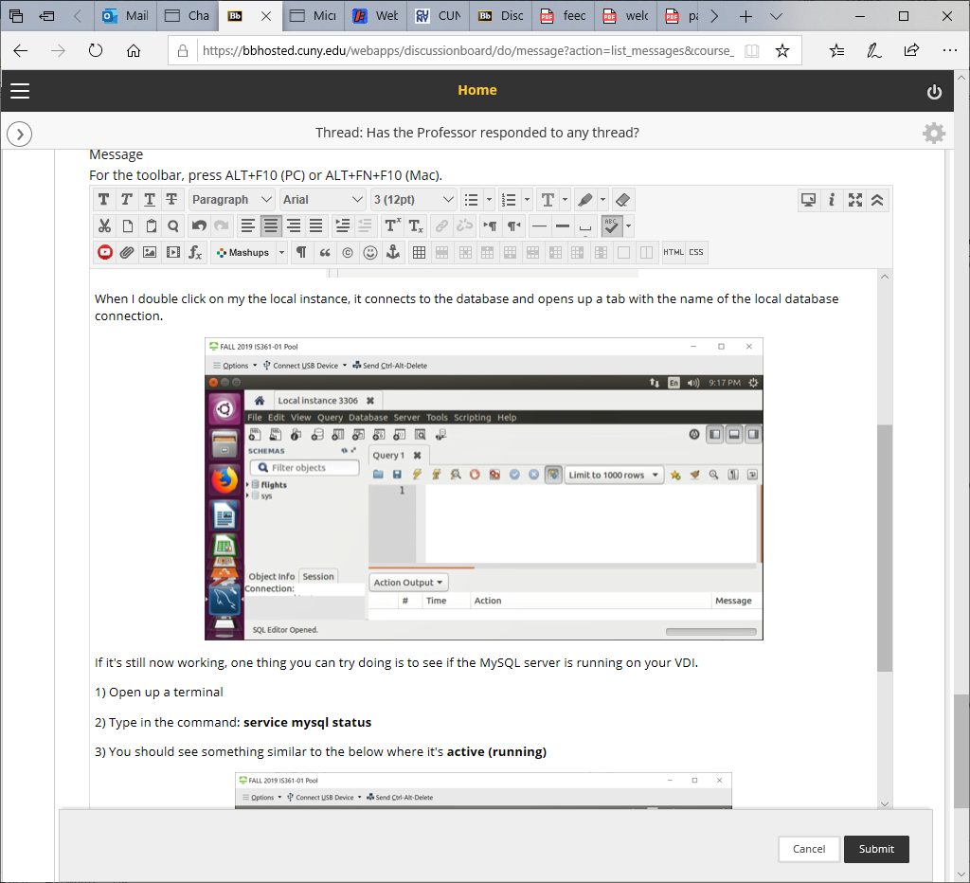

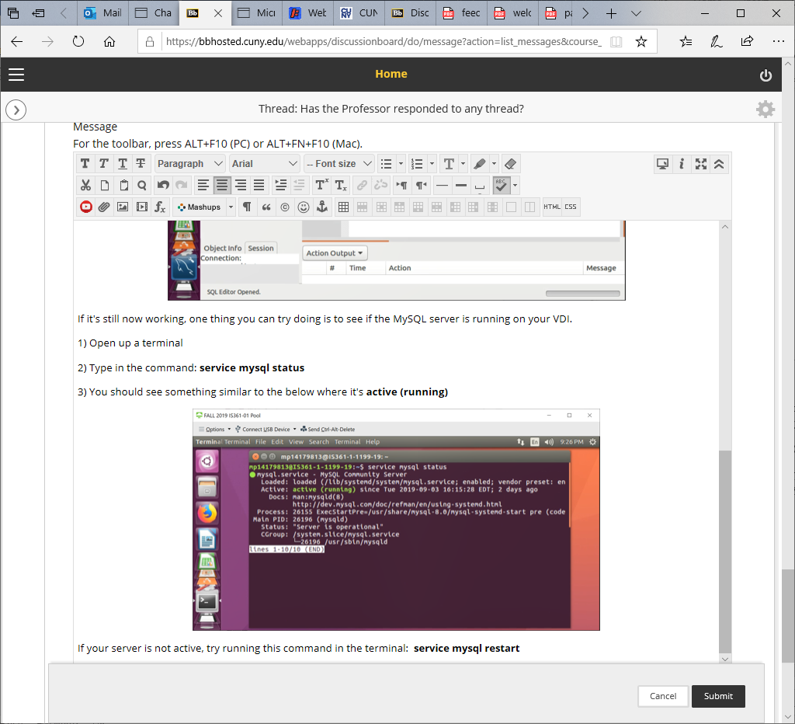

If it's still now working, one thing you can try doing is to see if the MySQL server is running on your VDI.

1) Open up a terminal

2) Type in the command: **service mysql status**

3) You should see something similar to the below where it's **active (running)**

The steps that you outlined above are normally all the steps needed to connect. Did you ever uninstall and reinstall MySQL Server or Workbench? If you did, do you recall if you were prompted to set a root password? When I updated my settings after receiving the email from the SPS Helpdesk, my setup looks like the below:

When I double click on my the local instance, it connects to the database and opens up a tab with the name of the local database connection.

If it's still now working, one thing you can try doing is to see if the MySQL server is running on your VDI.

1) Open up a terminal

2) Type in the command: service mysql status

3) You should see something similar to the below where it's active (running)

If your server is not active, try running this command in the terminal: service mysql restart

If your server is not active, try running this command in the terminal:  **service mysql restart**